Part 2

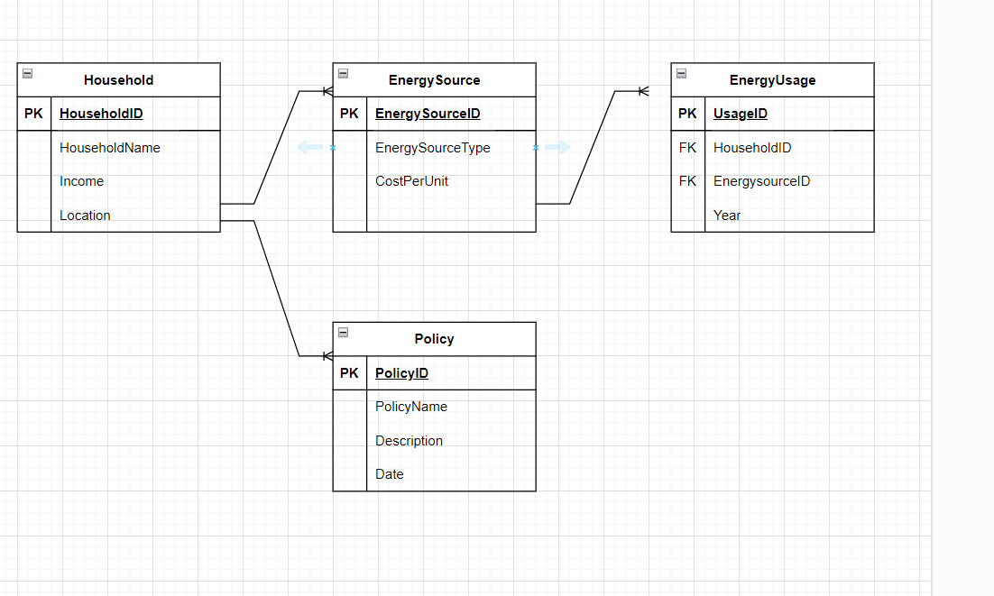

CREATE DATABASE EnergyAccessDB;

USE EnergyAccessDB;

CREATE TABLE Household (

HouseholdID INT AUTO_INCREMENT PRIMARY KEY,

HouseholdName VARCHAR(255) NOT NULL,

Income VARCHAR(50),

Location

);

CREATE TABLE EnergySource (

EnergySourceID INT AUTO_INCREMENT PRIMARY KEY,

SourceType VARCHAR(100) NOT NULL,

CostPerUnit DECIMAL(10, 2) NOT NULL

);

CREATE TABLE EnergyUsage (

UsageID INT AUTO_INCREMENT PRIMARY KEY,

HouseholdID INT,

EnergySourceID INT,

Year INT,

FOREIGN KEY (HouseholdID),

FOREIGN KEY (EnergySourceID)

);

CREATE TABLE Policy (

PolicyID INT AUTO_INCREMENT PRIMARY KEY,

PolicyName VARCHAR(255) NOT NULL,

Description TEXT,

Date DATE

);

Part3

SELECT HouseholdID, HouseholdName, Income

FROM Household;

SELECT EnergySourceID, SourceType, CostPerUnit

FROM EnergySource;

SELECT PolicyID, PolicyName, Description, Date

FROM Policy;

THE PITCH DECK LINK

https://pitch.com/v/1-addressing-energy-access-inequality-3y2c6m